Email Etiquette: Guidelines for Writing Emails to your teachers
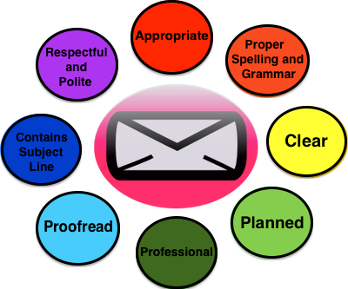
The way in which you communicate and present yourself when writing to your teachers is extremely important.

When you write to a teacher, you should view it as a professional exchange. How you choose to interact conveys your level of seriousness and professionalism. It not only affects how your teacher views you, but it also determines how much time they are going to take to deal with your issues. If you come off as rude, clueless, or irresponsible, then it will affect how your teacher responds. This will have consequences for how the teacher interacts with you and possibly also how they evaluate you. As with any professional interaction, it is in your best interest to be respectful, polite, and courteous when communicating with teachers. Your emails, and the words you use, are a reflection of you and your attitudes.

Here are a few basic tips that you should follow when emailing your teachers.
- View an email to a teacher as a professional interaction. Keep in mind that you are not texting with a friend or writing a casual message to an acquaintance -- this is a professional interaction with someone who is an expert in their field and in an official position to evaluate you and grade your work. Your emails should contain the proper parts of letter, convey respect and courtesy, and reflect the fact you are a serious student. Here are a few specific tips:
  - Begin your email by addressing your teacher by title and name, and end your email with a closing and your signature. Begin your email with a greeting addressing the teacher politely, such as "Dear Ms. Smith" or "Hi Mr. Jones". After your message, end with a closing and signature, such as "Sincerely, YourName" or "Thanks, YourName". You should always use your full name. Remember that your teacher has more than 130 students and may have more than one student with your first name.
  - Be clear and concise. Make sure your message is easy to understand, and that you do not go into unnecessary details. Writing in a professional manner does not mean your message must be long. If your question is short or direct, a one-sentence email (provided it includes a greeting and signature) is fine.
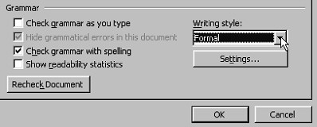
  - Use correct spelling and proper grammar. If your email is filled with spelling and grammar errors it indicates one of two things: (1) You are woefully uneducated; or (2) You care so little about the person you are writing that you are unwilling to take the time to write properly. Neither is something you want to convey to your teacher. Use complete sentences. Use proper spelling, capitalization, and grammar. Be particularly careful using homophones, such as there/their/they're or to/two/too. Do not use grammatically incorrect colloquialisms, such as "gonna" or "could of". Do not use emoticons. Do not use text abbreviations, such as "R U gonna have ur class 2morrow cuz i won't b there".
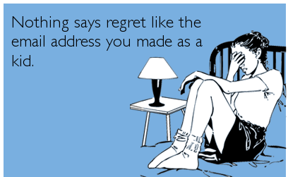
- Use Proper Email Etiquette. In addition to the content of your message, there are other technical aspects to being professional and courteous in email.
  - Use an account with an appropriate email address. You should use your school email account. Cutesy, offensive, or childish email addresses are inappropriate in professional interactions, and it is a big mistake if you use one. If you have an email address of the form sweet_darlin_nikki@yahoo.com or cutie_pie_98@hotmail.com or mikey_g@aol.com then it's time to retire that address in favor of something more grown up and more professional. If you don't want to use your school email address, create a Gmail account of the form firstname.lastname@gmail.com. If you like, you can forward email from your other accounts to your new one. Your email address, including both the username and the domain name, is a reflection of your professionalism. (See this comic by The Oatmeal.) In addition, silly email addresses have a much higher chance of getting flagged as spam and never making it to your teacher's inbox.
  - Make sure the emails you send display your full name in the "From" field. In your email preferences, you can set the "From Name" that recipients see when they get your emails. This should be set to include both your first name and last name. It should not be your email address; it should not be only your first name; and it should not be a nickname or a handle. When your teacher looks at their inbox, it helps them if they can see immediately who the message is from, and recognize you as a student in their class. If you're not sure how the "From Name" appears in emails from your account, send an email to yourself and take a look. Again, emails that don't display your full name have a higher chance of getting flagged as spam and never making it to your teacher's inbox.
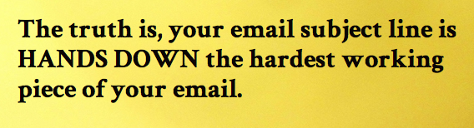
  - Always use an informative subject line. Do not leave the subject line blank. Subject lines help the recipient to determine what the email is regarding before opening the message. The subject line also aids in organizing and locating email in the future. It is helpful if your subject contains the course name and a brief explanation of the nature of the email. For example: "Math 3333-Question about Homework" or "Math 2331-Request for Meeting".
- Do Not Waste Your teacher's Time. teachers are incredibly busy, and teaching is not the only part of their job. If you send emails with trivial requests, or if you ask a teacher to do things you could easily do yourself, it indicates that you do not respect your teacher or value their time. In addition, be very careful you do not send emails that convey the message "I need to know this, and you need to tell me right now." Here are some common student mistakes that you should avoid:
  - Do not email to ask basic questions you can answer for yourself. If you don't know what a word means, try looking it up in the index of the textbook. If you don't know how to do an exercise, check your notes to see if a similar one was done in lecture. Class policies, such as office hours, assignment details, writing guidelines, grading criteria, policies on missed classes and exams, etc. are almost always addressed in the syllabus. If something is still not clear, then by all means ask your question --- but first attempt to answer the question yourself and only write if you need further clarification.
  - Do not make demands. If you are asking for anything requiring time or energy, you should be courteous and phrase it as a request. Do not presume your request will be granted or that you automatically deserve special accommodations. If you miss an exam, for whatever reason, do not write and say "I missed an exam. When can I make it up?". Instead, explain why you have extenuating circumstances, and ask the teacher if they will allow you to make up the exam. Likewise, if you have special needs or a disability that requires accommodation, do not write the teacher an email telling them what they have to do. Explain your circumstances and your needs, and ask politely for accommodation.
  - Do not email to explain why you missed class. Most teachers are tired of these kinds of excuses, and most do not care. If something serious has occurred, or you need special accommodations, you should go to office hours and discuss it in person.
  - Do not write your teacher asking for copies of their notes because you missed class. teachers are busy, and it's not their responsibility to do more work because you didn't come to class. Instead, ask a classmate.
  - Do not write asking for extra credit. If you don't understand why, see this page.
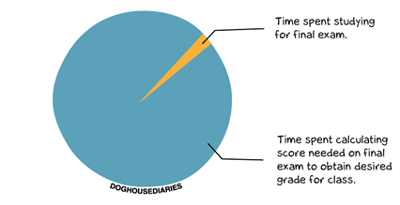
  - Do not email to ask what your current grade is, or how many points you need on the final to get a certain grade in the class. You should be keeping track of your scores on homework and exams using Infinite Campus. The syllabus describes how the portions of the course are weighted and how your final percentage in the class is calculated. You should be able to calculate your current grade and what score you need to get a certain final percentage in the class. If you are not keeping track of your scores on homework and exams, it shows you do not care very much about the class or your academic performance. If you are concerned about your grade, go to office hours and talk about it in person rather than writing an email.
- Before Sending an Email, Check That What You Have Written is Appropriate. Remember that you are engaging in a professional exchange, not writing to a friend. Here are some tips:
  - Do not use your email to vent, rant, or whine. If you have a complaint, or are not happy about something, explain yourself calmly and ask if anything can be done. You may very well be frustrated about a situation, but sending an angry email will not help things. In situations like this, it is also often more helpful to talk to the teacher in person rather than send an email -- particularly since tone and intent can often be misinterpreted in emails.
  - Do not share inappropriate personal details. Detailed information on your love life, health issues, home life, or family situation are often not appropriate or even relevant. Discuss only what relates to the class. If something serious is occurring in your life, talk to the teacher in person.
  - Be respectful, and consider whether anything you have written might sound rude or offensive to your teacher. For example, don't flippantly say that you slept through the teacher's class, or say that you hate the subject or course, or that you think the teacher is too strict. These things are all offensive and inappropriate. Likewise, do not write your teacher asking if they covered anything important on a day you missed --- by doing so you imply that most of what the teacher covers in class is not importan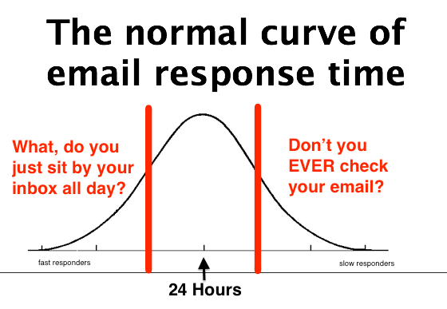
- Allow Time For a Response. teachers are busy and have many other job responsibilities in addition to your class. Also, you should not expect teachers to be responding to email at night or first thing in the morning. Allow up to 24 hours for a teacher to reply -- possibly more if it is a weekend or holiday.
- Do Not Use Email as a Substitute for Face-To-Face Conversation. Most teachers complain that students fail to take advantage of office hours and speak with them in person. Many issues are often better handled in person than by email. Discussions about assignments or grades, questions about homework problems, requests for a letter of recommendation, and in-depth conversations about academic topics are all best done in person.

This comic by Jorge Cham of Ph.D. comics nicely summarizes many of the issues discussed above:

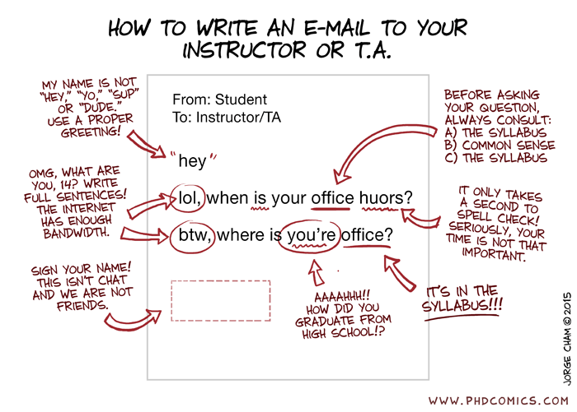

https://www.math.uh.edu/~tomforde/Email-Etiquette.html

