Online Learning and Digital Artifacts Portfolio
Alexis Hoffmann
OTL534 – ID Authoring and Internet Apps for Education
Colorado State University – Global Campus
Marie Larcara, Ed. D
8/5/2018

According to Thinking by Tim Brown, it takes a certain personality to be considered a design thinker. Empathy, integrative thinking, optimism, the desire to experiment and collaboration are all key characteristics that are required to be successful when using the design thinking method. There is a process that must be followed in order for this to be worthwhile with the main focus being on a human-centered approach (Brown, 2008). This means that I must keep my students at the forefront of my mind when creating my courses and how I will implement them as they will be the ones utilizing the programs to their fullest.
My focus for this course was on curriculum, which is where I felt I had the most control. Thus, I focused on redesigning my courses to be blended (with online components integrated throughout it).
Module 3: Tagging Content
My public pinboard can be found on the Schoology site under Course Resources at:
https://app.schoology.com/page/1663571112
Tagging information resources with keywords can drastically change how we find and store information (Educause Learning Initiative, p. 1). The hardest part was determining how to create the tags that I wanted so it would be easier to find the resources on the pinboard in the future. I began by labeling each one based off the grade level for the resource, then began tagging with other specific terms (such as government, primary source analysis, etc.). This will make it easier to find links that relate to the specific information I need. Because some of the resources can be used for more than one grade level or class, tagging the link with specific skills (critical_thinking or primary_source_documents) allows me to search through all of the different links I have available so that I do not accidentally miss a resource because it was originally labeled under one class over another (as is the case with several of my bookmarks in Chrome).

Module 4: The Object and the Process
My digital learning object can be found in Schoology here: https://app.schoology.com/page/1663707768
I began this process by deciding what lesson I wanted to incorporate. I decided that since my courses all have aspects of students analyzing documents, I should create a lesson revolving around this idea. The document based question (DBQ) is designed to test the ability to simultaneously apply several historical thinking skills. These include historical argumentation, use of relevant historical evidence, contextualization, and synthesis. This lesson plan should help my students to dissect the question, to organize their thoughts, and to analyze the documents so that you can begin to write a comprehensive essay.
Module 5: Earning and Displaying Badges
My earned badges are on display on my Schoology page here: https://app.schoology.com/course/1594091933/materials?f=124664545
I first began this process by completing the tasks asked of me through this module. A majority of the badges I earned were through Code Academy because that is what I was able to find the most badges for as well as the fact that they offer a plethora of lessons that you may earn badges on. I learned the basics for HTML and then played around with the Python program as well. For CodeAcademy, you can find the badges I have earned here:
https://www.codecademy.com/users/alexisHoffmann9532233714/achievements
I have always been fascinated with space, I did some digging and found that NASA has a program where you can earn different badges through the STEM Educator Professional Development Collaborative.
Here, I found a variety of badges to help incorporate STEM ideas into the classroom. I also enjoyed learning more of the history of the early NASA's Orion spacecraft, its Launch Abort System (LAS) and the upcoming Ascent Abort-2 flight test. It also was interesting for me to learn some content knowledge about mass properties (physical sciences and mathematics) and how engineers apply these concepts to vehicle design (workforce connections) which were some of the lessons I needed to work through to earn the badge.
I believe that I will begin with using the badges that are already part of the Schoology program and see how motivating it is for my students. Since Schoology already has the basic badges for attendance, participation, homework, etc., I feel that this will be a good start for my students. Schoology also has a feature where I can either import badges from other locations or even create my own to be used within the program (as seen in the screenshots below).
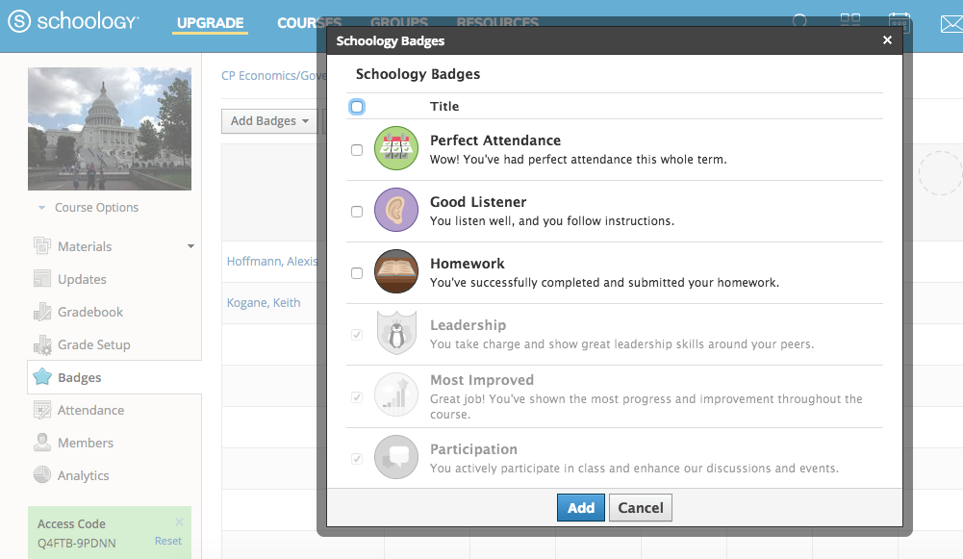
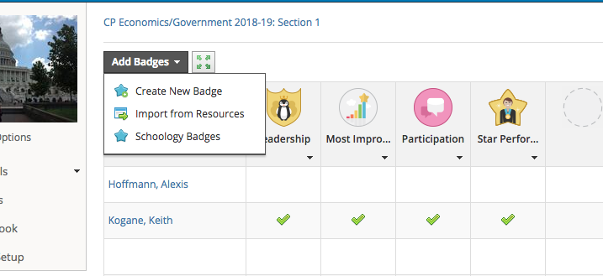
Module 6: Gamification Lesson: Escape Room Review
My game can be found on my site here:
https://app.schoology.com/assignment/1649639128/assessment_preview
When reading about gamification, it became clear how much I already use some of these ideas within my teaching currently. The idea of using games in an educational setting is definitely not new, but as the Tom Vander Ark states in his article on gamification, the widespread use of “game-based adaptive learning systems, the explosion of mobile-learning applications, and the growing use of game-based strategies makes gamification one of the most important education trends of this decade”, (Vander Ark, 2014, para. 1).
“In the classroom, the “Escape Room” format should involve students working together, against the clock, to solve a series of puzzles using existing and fresh knowledge from their studies and from clues and sources which have been left around the room. They can be great for introducing a fresh topic, consolidating existing knowledge and introducing fresh learning into the classroom in a fresh and engaging way”, (Design educational "escape rooms" for your students!, 2017, para. 3).
The first step is deciding what information you want your students to show you they know. For the purposes of a 53 minute class period such as those that I have, I know I need to probably choose no more than a few main concepts that will be reviewed in different puzzles/tasks. For the AP World Review, however, I decided to make it a double class period (my teaching partner would have to give up their period in order for me to accomplish this but it would ensure that we could get through the entire lesson review in time).
I have heard of teachers doing these station by station if there is enough room or if they can have students enter multiple physical rooms to escape from. Since I do not have that ability given that I have a double classroom containing 55-60 students, I needed to find another way to accomplish this. Thus, my idea was to create a series of “rooms” that were essentially a one page worksheet that represented a room that students needed to solve the riddle for in order to “unlock” it to go to the next room (get the next worksheet).
It’s often good to make one or two tasks fairly simple. Too many challenging tasks can leave our less confident students ready to quit (Anne, 2017, para. 10). The key is a balance between an easy, moderate, and challenging tasks. I like the idea of creating escape rooms for the classroom and after reading another article on what supplies you need, I think I could come up with a way to create a series of activities for my students using a variety of puzzles and games for them to solve. In order to make sure I can reach all my students (whether they are in my Honors courses or a student who is on an I.E.P. , 504 Plan or speaks English as a second language, I can add clues that make sure they do not get stuck to quickly or give up. I could embed a clue in a short reading. Bold letters in the reading that can be arranged to spell out a clue such as “s-e-a-r-c-h u-p”, then hide the next activity and clue in the location that the clue pointed them towards (Potash, n.d).

Module 7: User Feedback Form
My course evaluation/use feedback form can be found: https://app.schoology.com/page/1663563112
My student’s feedback can be found: https://tinyurl.com/ycjoe8l9
Vickie Davis stated that “great teachers are never afraid of having or inviting hard conversations”, (Davis, 2015, para. 10). This is one of best practices that has also helped me to be a better teacher because it allows me to take a step back and think about what I need to do to change lessons. Based on the feedback provided by my student, I know that I need to make my interactive lecture information easier to understand as well as clarify my overall explanations of assignments. I have to remember that when I create online assignments that I will not necessarily be there to help walk them through information or give support if my instructions are not clear.
Sharing my Work
I have been creating an online resources site since the beginning of my Master’s program. Here I share all lessons, reflections and resources I have gathered throughout the course of my program. The main site can be found here: http://hoffmannholodeck.weebly.com/ and clicking on the OTL534 link provides educators and potential employers to ability to see my design process and what has currently been created.

References

Anne, D. (2017, May 22). How to create an escape room your students will love!
Retrieved from
https://blog.teacherspayteachers.com/create-escape-room-students-will-love/
Brown, T. (2008). Design Thinking. Harvard Business Review. 84-92.
Davis, V. (2015, July 21). 3 Ways of Getting Student Feedback to Improve Your Teaching.
Retrieved from
https://www.edutopia.org/blog/student-feedback-improves-your-teaching-vicki-davis
Design educational "escape rooms" for your students! (2017, June 04). Retrieved from
https://www.classtools.net/blog/educational-escape-rooms-as-a-lesson-format/
Educause Learning Initiative. 7 things you should know about social bookmarking. (2005, May).
Retrieved from https://www.educause.edu/ir/library/pdf/eli7001.pdf
Potash, Betsy. How to use escape rooms in your classroom & watch engagement
boom. (n.d.). Retrieved July 22, 2018, from
https://boredteachers.com/blogs/the-faculty-room/how-to-use-escape-rooms-in-
your-classroom
Vander Ark, T. (2014, February 19). Eight principles of productive gamification. EdWeek.
Retrieved from
http://blogs.edweek.org/edweek/on_innovation/2014/02/8_principles_of_productive_
gamification.html

